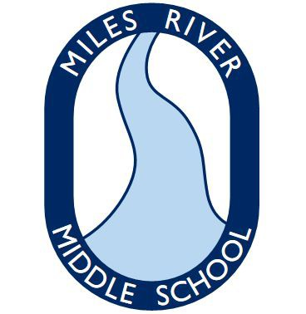HAMILTON-WENHAM REGIONAL SCHOOL DISTRICT Miles River Middle School Health Office
787 Bay Road
Hamilton, MA 01982

Telephone: 978-468-0390 Maribeth Ting, MSN, RN School Nurse
Fax: 978-468-0450

CONSENT FOR RELEASE OF INFORMATION AND/OR TO COMMUNICATE

Student DOB

I hereby give permission for the Hamilton Wenham Regional School District to exchange school records and other pertinent information to and/or communicate with:

Signature of parent or guardian Date

Print name

The Hamilton-Wenham Regional School District does not discriminate in its programs, activities or employment practices based on age, race, color, national origin, religion, gender, sexual orientation or disability.

